

**Project Report on**

**Distance Measure Using**

**Ultrasonic sensor**

**Department of Computer and Information Technology Batch 2019**

**Project Advisor**

*Engr. Nabeela Maham*

**A I T**

Submitted by

Muhammad Usman Saleem GR-051

Sajjad Ali GR-047

S.M.Ahmed Termizi GR-050

Muhammad Faraz GR-013

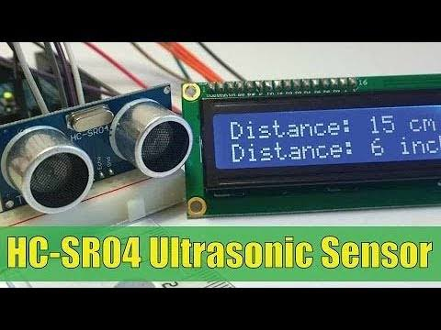

** DEPARTMENT OF COMPUTER AND INFORMATION TECHNOLOGY**

**Aligarh Institute of Technology University Road, Karachi – 75300**

**January 2019**

**Department of Computer and Information Technology Batch 2019**

**Aligarh Institute of Technology**



**Certificate**

This is to be certified that **Muhammad Usman Saleem , Sajjad Ali , S.M.Ahmed Termizi**  and **Muhammad Faraz**  students of 2nd year C.I.T of Computer and Information Technology Department have completed their major project entitled

**Project Title**

In the area of **Microprocessor and Architecture** under the guidance and supervision provided at **Aligarh Institute of Technology**

**Supervision:**

Engr. Nabeela Maham Sir: Shahid Jamil

Junior Instructor, C.I.T H.O.D ,C.I.T

**Signature Signature**

**Abstract**

The project is designed to develop distance measurement system using ultrasonic waves and interfaced with Arduino. We know that human audible range is 20hz to 20khz. We can utilize these frequency range waves through ultrasonic sensor HC-SR04.The advantages of this sensor when interfaced with Arduino which is a control and sensing system, a pro per distance measurement can be made with new techniques. As large amounts are spent for hundreds of inflexible circuit boards, the Arduino will allow business to bring many more unique devices. This distance measurement system can be widely used as range meters and as proximity detectors in industries. The hardware part of ultrasonic sensor is interfaced with Arduino. This method of measurement is efficient way to measure small distances precisely. The distance of an obstacle from the sensor is measured through ultrasonic sensor. After knowing the speed of sound the distance can be calculated.

**Table of Content**

PROJECT REPORTS

**PROJECT INTRODUCTION4**

**CODE SECTION5**

**Code Write6**

**HARDWARE SECTION7**

**Component Description**7

Ultrasonic Sensor8

LCD Display(16x2) With I2C Module9

Bread Board11

Jumper Wires12

Battery13

Switch13

Arduino Nano14

**CIRCUIT DIAGRAM16**

**REAL TIME IMAGE17**

**FEATURES/APPLICATIONS17**

**SYSTEM REQUIRMENT18**

**Hardware Component**18

**Software Used**18

**REFRENCES18**

**FEEDBACK TABLE19**

**Project Report**

**Introduction/Background**

Today’s the developing world shows various adventures in every field. In each field the small requirements are very essential to develop big calculations. By using different sources we can modify it as our requirements and implement in various field. In earlier days the measurements are generally occur through measuring devices. But now a day’s digitalization as is on height. Therefore we use a proper display unit for measurement of distance. We can use sources such as sound waves which are known as ultrasonic waves using ultrasonic sensors and convert this sound wave for the measurement of various units such as distance, speed. This technique of distance measurement using ultrasonic in air includes continuous pulse echo method, a burst of pulse is sent for transmission medium and is reflected by an object kept at specific distance. The time taken for the sound wave to propagate from transmitter to receiver is proportional to the distance of the object. In this distance measurement system we had ultrasonic sensor HC-SR04 interfaced with Arduino Nano. Programming and hardware part of ultrasonic sensor interfacing with Arduino Nano.

**Code Section**

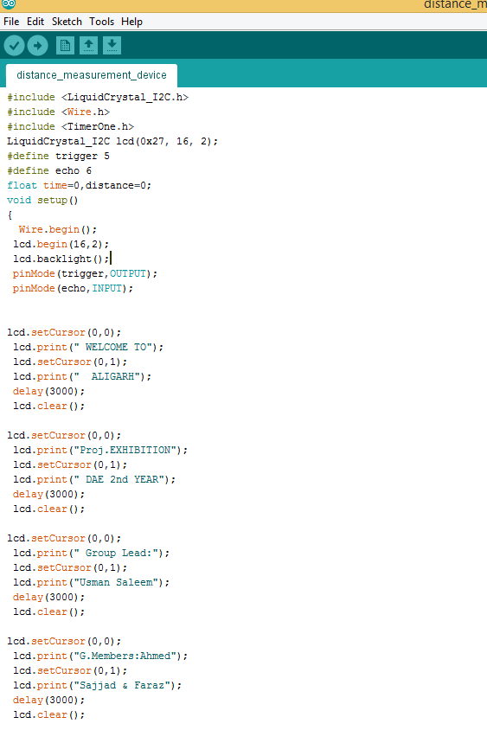

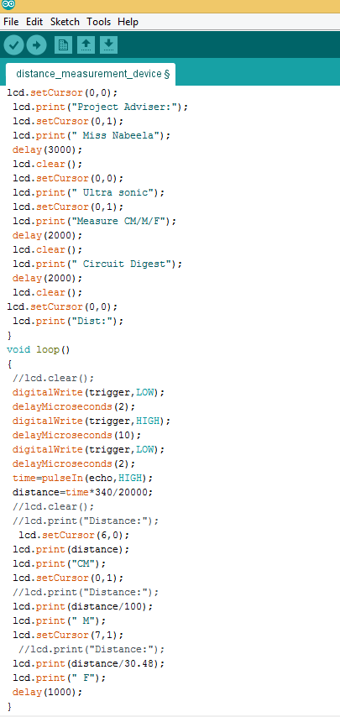

**Hardware Section**

* **Component Description**

We used to some components in this project.

1. **Ultrasonic Sensor**
2. **LCD Display(16x2) With I2C Module**
3. **Bread Board**
4. **Jumper Wires**
5. **Battery**
6. **Switch**
7. **Arduino Nano**

**ULTRASONIC SENSOR:**

It emits an ultrasound at 40,000 Hz which travels through the air and if there is an object or obstacle on its path it will bounce back to the module. Considering the travel time and the speed of the sound you can calculate the distance.

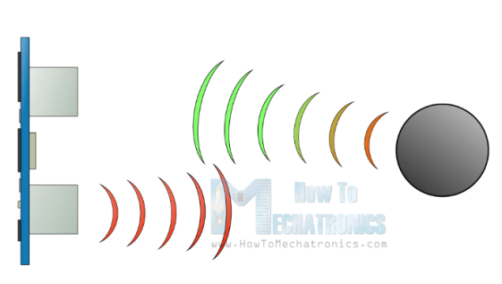

The HC-SR04 ultrasonic module has 4 pins, Ground, VCC, Trig and Echo. The ground and VCC pins of the module needs to be connected to the ground and the 5 volts pins on the Arduino Board respectively and the trig and echo pins to any digital I/O pin on the Arduino Board.

In order to generate the ultrasound you need to set the trig on a high state for 10us.that will send out an 8 cycle sonic burst which will travel at the speed sound and it will be received in the Echo pin. The Echo pin will out-put the time in microseconds the sound wave travelled.

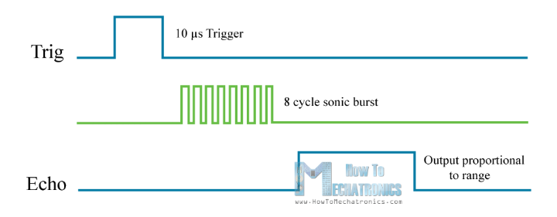  
For example, if the object is 10cm away from the sensor, and the speed of the sound is 340m/s or 0.034 cm/us the sound wave will need to travel about 294 u seconds. But what you will get from the Echo pin will be double that number because the sound wave needs to travel forward and bounce backward. So in order to get the distance in cm we need to multiply the received travel time value from the echo pins 0.034 and divide it by 2.

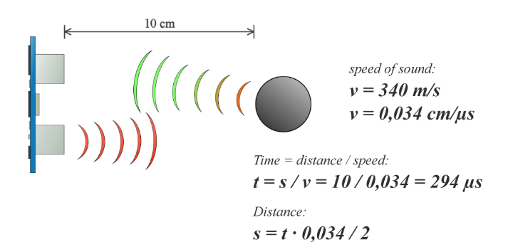

**LCD Display(16x2) With I2C Module:**

LCD modules are very commonly used in most embedded projects, the reason being its cheap price, availability and programmer friendly. Most of us would have come across these displays in our day to day life, either at PCO’s or calculators. The appearance and the pin outs have already been visualized above now let us get abet technical.

16x2 LCD is named so because; it has 16 Columns and 2 Rows. There are a lot of combinations available like, 8x1,8x2,10x2,16x1, etc. but the most used one is the 16x2 LCD. So, it will have (16x2=32) 32 characters in total and each character will be made of 5x8 pixel Dots.

**Features of 16x2 LCD module:**

* Operating Voltage is 4.7v to 5.3.
* Current consumption is 1mA without backlight.
* Alphanumeric LCD display module, meaning can display alphabets and numbers.
* Consists of two rows and each row can print 16 characters.
* Each character is build by a 5x8 pixel box.
* Can work on both 8-bit and 4-bit mode.
* It can also display any custom generated characters.
* Available in Green and Blue Backlight.

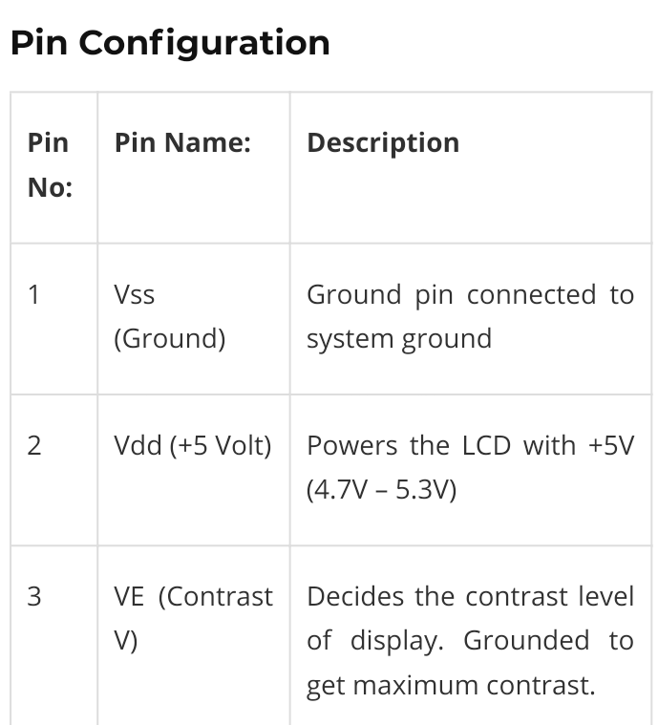

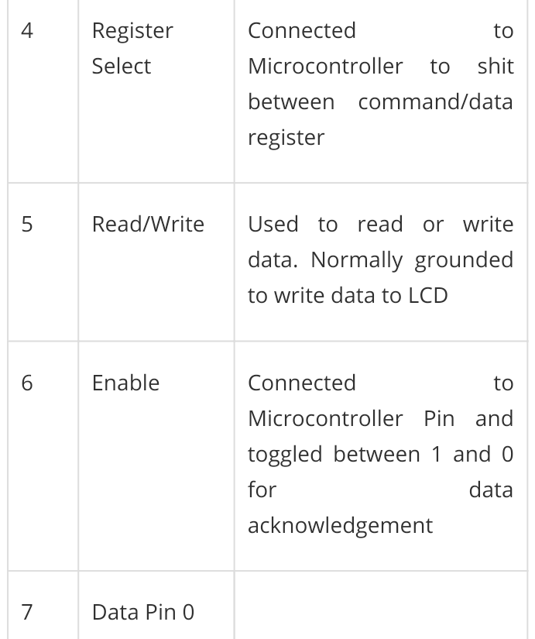

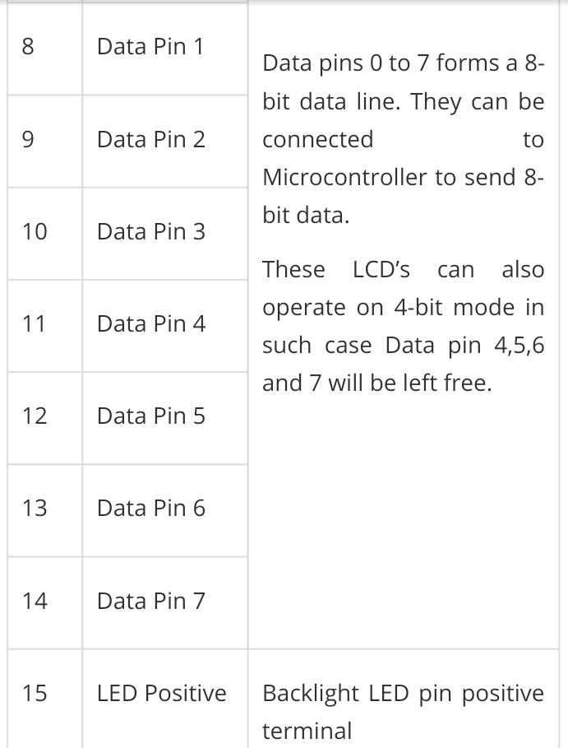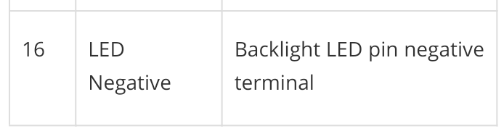

**Bread Board:**

A **breadboard** is a solder less device for temporary prototype with electronics and test circuit designs. Most electronic components in electronic circuits can be interconnected by inserting their leads or terminals into the holes and then making connections through wires where appropriate.

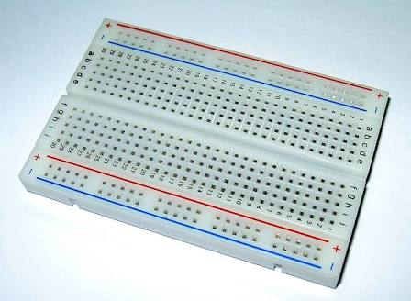

**Jumper Wires**

**Jumper wires** are simply **wires** that have connector pins at each end, allowing them to be used to connect two points to each other without soldering. **Jumper wires** are typically used with breadboards and other prototyping tools in order to make it easy to change a circuit as needed.

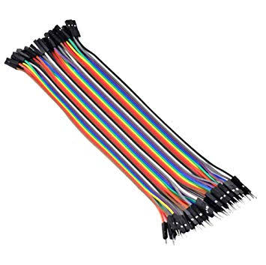

**Battery :**

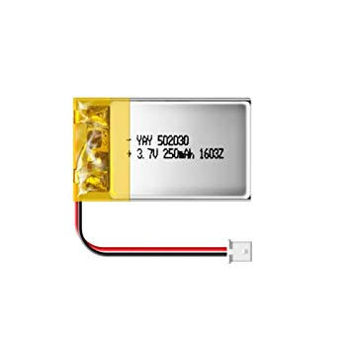

**Battery Module:**

This linear charger board allows you to charge lipo battery Using either a mini micro USB connector or a 4.5V-5.5V input.

**Specifications:**

RED: **Charging**

GREEN: **Fully charged**

INPUT VOLTAGE: **4.5V-5.5V**

CHARGE VOLTAGE: **4.2V**

CHARGING PRECISION: **1.5%**

DIMENSIONS: **22mm x 16mm**

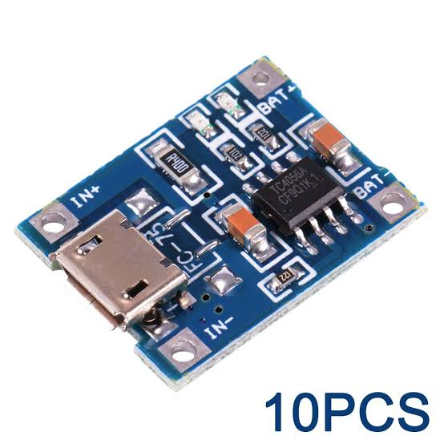

**Switch:**

A push-button (also spelled pushbutton) or simple button is a simple switch mechanism for controlling some aspect of a machine or a process. Button are typically made out of hard material, usually plastic or metal.

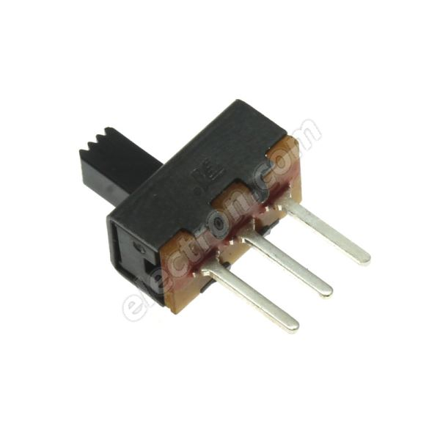

**Arduino Nano:**

The Arduino board is designed in such a way that it is very easy for beginners to get started with microcontrollers. This board especially is breadboard friendly is very easy to handle the connections. Let’s start with powering the Board.

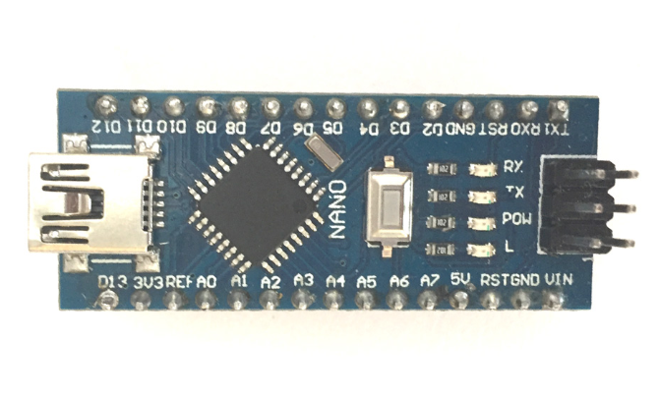

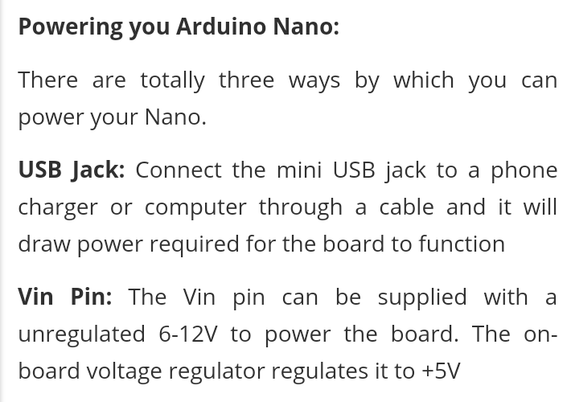

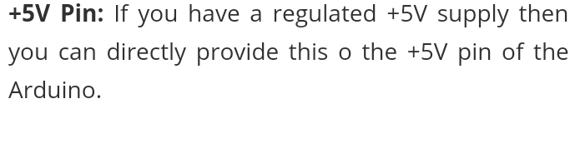

**INPUT / OUTPUT**

There are totally 14 digital pins and 8 analog pins on your Nano Board. The digital pins can be used to interface sensors by using them as input pins or drive loads by using them as output pins. A simple function like pinMode() and digitalWrite() can be used to control their operation. The operating voltage is 0V and 5V for digital pins. The analog pins can measure analog voltage from 0V to 5V using any of the 8 analog pins using a simple function liken analogRead()

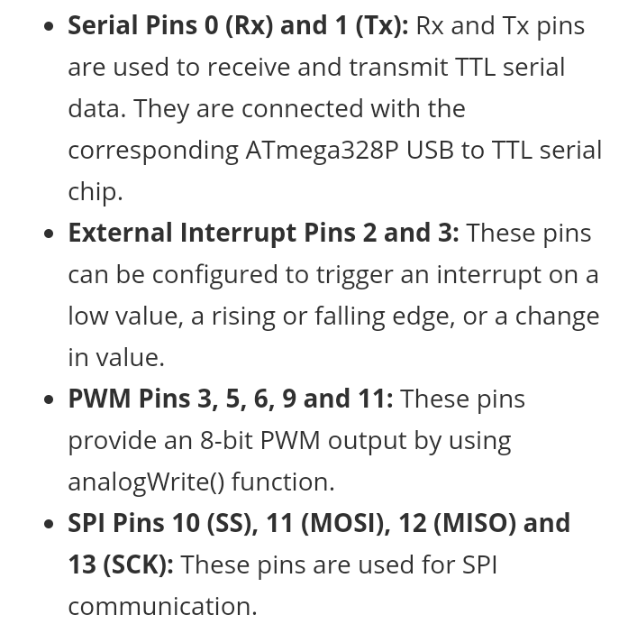

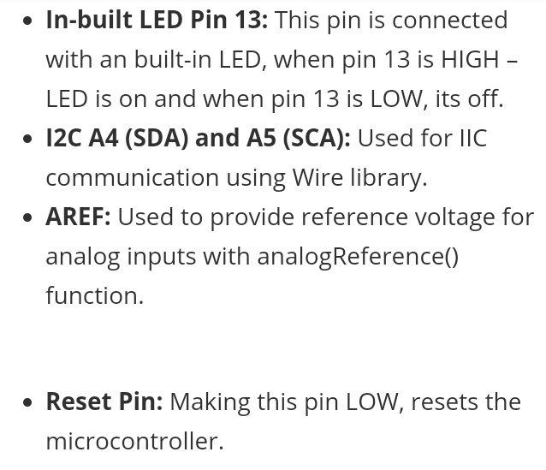

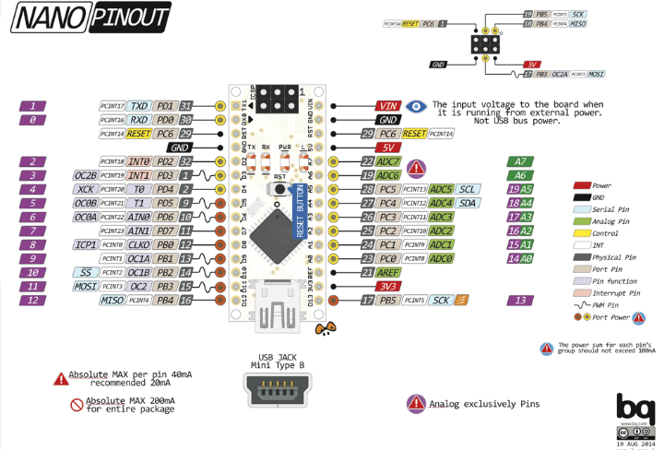

* **Circuit Diagram**

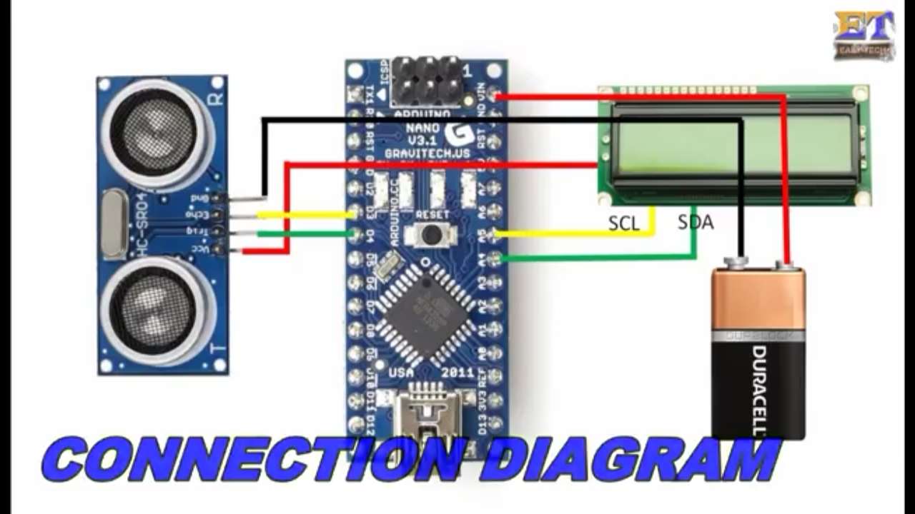

* **Real Time Image**

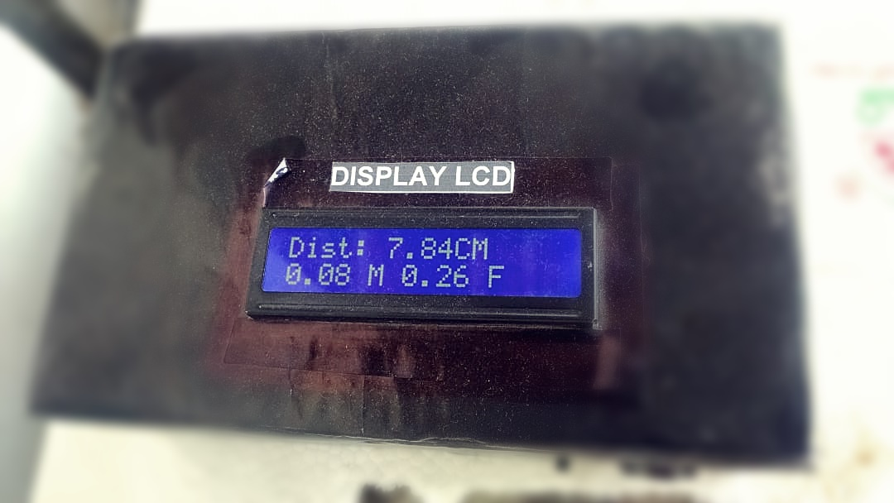

**Features /Application**

Distance measurement is a part of the day to day life. Sometimes, the size of a room needs to be measured before shifting and adjusting furniture into it or the dimensions of a table need to be measured for selecting it for study. Measurement of distance is something that is often done in daily life. Usually, for measuring distances, a measuring tape is used. However, the use of measuring tape has certain disadvantages.

First, it requires two persons to hold the measuring tape for taking a reading. Secondly, measuring tape requires careful alignment along the dimensions under measurement and the reading need to be taken carefully. Even sometimes measuring destination is not properly reachable or approachable. Considering these common disadvantages of the use of measuring tape, the idea of an ultrasonic distance measurer came up as a viable electronic solution for the problem.

The electronic distance measurer designed in this project is built on Arduino Nano, small and portable Arduino board popular for making handheld gadgets and it uses HC-SR04 ultrasonic sensor that can detect distances up to 4 meters. The range of the sensor used in the project is enough for day to day uses. The only limitation of the device is that being based on an ultrasonic sensor which measures distance by the reflection of the sound waves, it requires any corner or reflecting surface at the other end as a reference for distance measurement. So the device would not be much useful for measuring distances over open edges.

**System Requirement**

We have required in this project are given below

**HARDWARE COMPONENETS:**

* Arduino Nano
* Bread Board
* Ultrasonic Sensor
* Battery + Module
* Jumper Wires
* LCD + Module
* Switch

**SOFTWARE USED:**

* Using Arduino software version 1.8.5

**References**

[**https://bit.ly/2TVwCj**](https://bit.ly/2TVwCj)

[**https://youtu.be/ZpKAHmqExps**](https://youtu.be/ZpKAHmqExps)

[**https://components101.com/16x2-lcd-pinout-datasheet**](https://components101.com/16x2-lcd-pinout-datasheet)

**Feedback Table**

|  |  |  |  |
| --- | --- | --- | --- |
| **S.NO** | | **YOUR NAME** | **YOUR COMMENTS** |
|  | |  |  |
|  | |  |  |
|  | |  |  |
|  | |  |  |
|  | |  |  |
|  | |  |  |
|  | |  |  |
|  | |  |  |
|  | |  |  |
|  | |  |  |
|  | |  |  |
|  | |  |  |
|  | |  |  |
|  | |  |  |
|  | |  |  |
|  | |  |  |
|  | |  |  |
|  | |  |  |
|  | |  |  |
|  | |  |  |
|  | |  |  |
|  | |  |  |
|  | |  |  |
|  | |  |  |
|  | |  |  |
|  |  | |  |
|  |  | |  |
|  |  | |  |
|  |  | |  |
|  |  | |  |
|  |  | |  |
|  |  | |  |
|  |  | |  |
|  |  | |  |
|  |  | |  |
|  |  | |  |
|  |  | |  |
|  |  | |  |
|  |  | |  |